2019 Meagher County Christmas Stroll
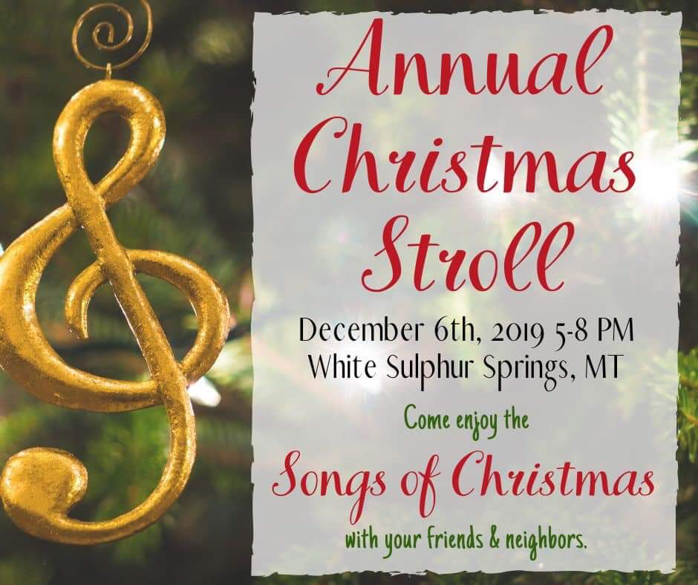
"Songs of Christmas"
5pm-8pm Friday, December 6, 2019
(you may choose to run an all day special or stroll
hours only feel free to alter your closing time)

IMPORTANT Information about this year
• The Chamber will be designating where the crafter's and home based businesses will be located they will NOT be able to pick a location on their own. Therefore, if they contact you please let them know they must fill out their form and return it to Smith River Custom Apparel or The Branding Iron Cafe to participate.
• The Stroll is from Snook's Diner to The Roadhouse / Garden Shop (This is so as to include all Brick and Mortar Stores in the Stroll that are on "our" main street)
• There will once again be the horse drawn wagon rides, kindly provided by The Teague family.
• There will be a decorating contest for any business that chooses to participate. It will be best use of Christmas Song provided by the Chamber. (we will give you your song by November 21st )
• Remember to have fun, enjoy yourselves and help promote what this Great Community has to offer!

Please return the bottom of this form so we may best put together the map and advertising information.

Business Name:
Business Phone:
Contact Person:
Email:

____Yes we will stay open and can house ____ Crafter's/ Home based Businesses

____Yes we will stay open but will not have any extra room for a crafter/home business

____Yes we will stay open limited hours ( )

____Yes we would like to participate in the decorating contest

Notes: If your going to have a special or have an event (ie: cookie decorating) at your business we can advertise that also, want to feature something, or introduce a new employee? Let us know here:

Return to: Smith River Custom Apparel or The Branding Iron Cafe
Mail to: Michele Walker at PO Box 551 WSS, MT 59645 or Email to: aonenterprisesllc@yahoo.com
Questions please Call 406-366-9611

